freETarget
Application Note: RS485

INTRODUCTION
FreeETarget Version 6 boards can be adapted to use RS485 communications. The advantage to this is significantly lower cable costs when using the target at a distance of two meters or more.
The conversion requires the addition of an RS485 to logic convertor and a USB to RS485 convertor. The logic convertor attaches to the main PCB by a small cable harness between the AUX and MFC connector and the convertor. From there the target and PC are connected by a low cost twisted pair cable.

REQUIRED PARTS
Item | Description | Amazon Code (US)
1 | FreeETarget firmware V6.3 or higher
2 | TTL to RS485 converter | B0CPFDJZXL
3 | USB to RS485 serial port converter | B07QSHRXLS
4 | Twisted pair wire (24 AWG) | B0CQMSWVYY
5 | Four conductor interface cable

INTERFACE CABLE
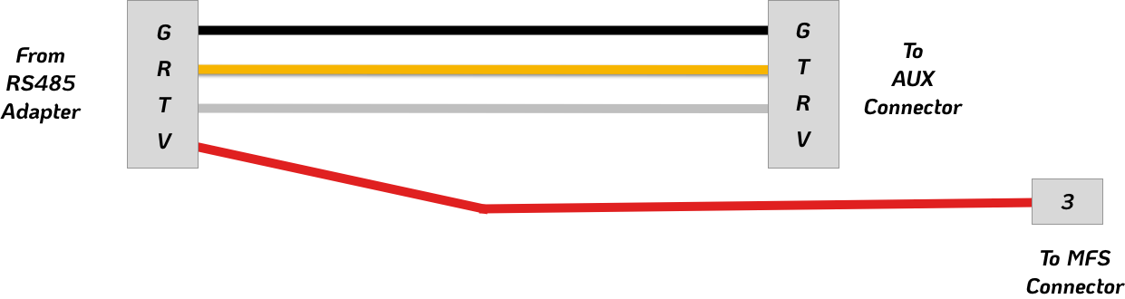

ASSEMBLY
- Connect the cable between the RS488 adapter and the target board. Note the power is provided by the MFS connector.
- Attach the USB to RS485 adapter to the PC
- Connect the PC to the target using the two conductor twisted pair. White to A, black to B

CONFIGURATION
Make sure that you are using target firmware V6.3 or higher.
Configure the AUX port to operate as RS485
{“AUX_MODE”:6}
Restart the target

USE
Using RS485 the target will behave as before using the USB cable. Just ensure that you are using the COMM port associated with the RS485 USB adapter.

